Navagraha

From Wikipedia, the free encyclopedia
Jump to: navigation, search
In Hindu astrology, the Navagraha (Sanskrit: , nine planets or nine realms) are the nine "planets", personified as celestial beings:
Name | English Name | Image | Yantra
Surya (सूर्य) | Sun | 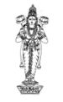 | 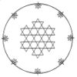
Chandra (चंद्र) | Moon | 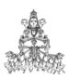 | 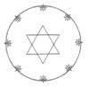
Mangala (मंगल) | Mars | 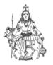 | 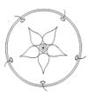
Budha (बुध) | Mercury |  | 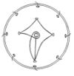
Brihaspati (बृहस्पति) | Jupiter | 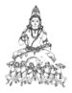 | 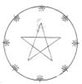
Shukra (शुक्र) | Venus | 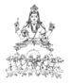 | 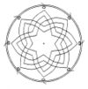
Shani (शनि) | Saturn | 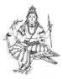 | 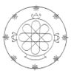
Rahu (राहु) | Head of Demon Snake  Ascending/North Lunar Node | 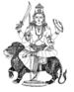
Ketu (केतु) | Tail of Demon Snake  Descending/South Lunar Node | 